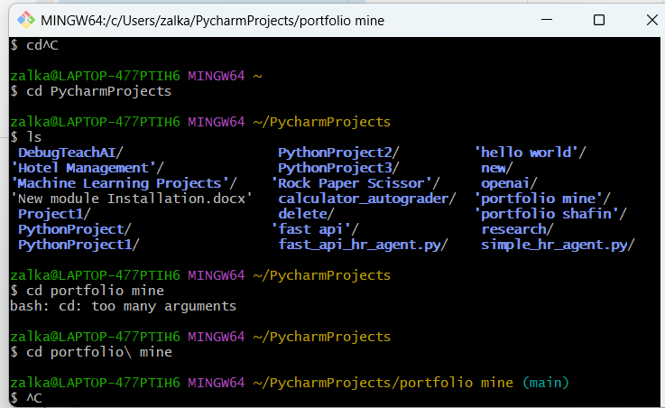

cd PycharmProjects
cd portfolio\ mine

================

git init
git remote add origin https://github.com/zakia16/portfolio.git
git add .
git commit -m "Upload portfolio"
git branch -M main
git push -u origin main

